EXPERIMENT-12

CURSORS

Aim:

1. Create a table with attributes students and marks.
2. Insert values into the table.
3. Create a procedure, and fetch the marks of given id using a cursor.
4. Create a procedure, and fetch the highest marks using a cursor.

* Create a table with attributes students and marks.



* Insert values into the table.



* Create a procedure, and fetch the marks of given id using a cursor.

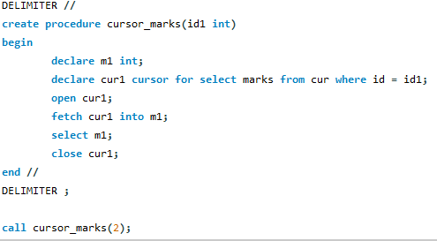



* Create a procedure, and fetch the highest marks using a cursor.

